Guidelines for Developing a Theory of Change
Prospective Grant Recipients
GCERF Performance & Impact Unit

Introduction

These guidelines aim to assist you as a prospective grant recipient in developing your Theory of Change. GCERF believes a well-developed Theory of Change is critical in achieving effective monitoring of performance and impact on the grant recipient’s project activities.

Developing a Theory of Change is a group/organization process that you and your organization should complete. As a potential grant recipient, you and your organization should own your Theory of Change by answering confidently, ‘Why are we doing what we are doing?

Developing a Theory of Change is an iterative process where the guidelines followed here may need to be repeated several times. Expect each repetition your Theory of Change will come closer to reaching the desired result of a well-developed Theory of Change.

The guidelines provided here will enable you as a prospective grant recipient to complete a draft Theory of Change as part of the concept note to be submitted to GCERF for consideration to receive funding. These guidelines will enable you and your organization to produce a Theory of Change of high quality if they are followed. A good theory of change not only will help you to understand your own project, but also will make your life easier in terms of communicating to partners and stakeholders what you want to do and achieve.

The various steps in developing a Theory of Change are listed below, along with details for each step. The first section, “Process Phase for Developing Theory of Change,” will guide you to brainstorm and generate a more extensive Theory of Change, creating an exhaustive list of problems, outcomes, and outputs. The following section, “Developing a Theory of Change,” will guide you from this brainstormed and large Theory of Change to a more focused- Theory of Change (see flowchart).

Process phase for developing a Theory of Change

STEP 1 – Identify the problems/challenges

Based on a review of the Country Needs Assessment/Country Strategy/overarching country-level Theory of Change (if available/applicable), generate a list of problems/challenges associated with a need or challenge identified in these documents. Even with these documents, brainstorming is encouraged, given the emerging field of P/CVE.

For example, the general need or challenge could be the need to rehabilitate and reintegrate foreign terrorist fighters (FTFs) upon return to their home country. The problems/challenges generated could include the lack of psychosocial counseling for these FTFs and their families, the lack of jobs and training opportunities for these FTFs, and the absence of government policies to support reintegration.

These problems should be as evidence-based and as specific as possible. Here is one of your significant assets as a civil society organization with knowledge of what is happening in the community: you probably know the community dynamics and the specificities of the problem. Thus, use this step to your advantage: be specific. Instead of saying the community does not feel connected to the government, specify exactly which level of government. Or specify which groups are engaging in violence against each other instead of referring to inter-community violence.

You may also want to consider what is driving people to become violent or to rely on violence as a solution. For example, regarding herders-farmers conflict, some farmers might feel they will not get justice when animals belonging to pastoralists destroy their farms. Thus, they might ending up creating or relying on non-state armed groups to ‘defend’ themselves, which might trigger pastoralists to do the same (and vice-versa). In this case the problem is not only the conflict between the two groups, but also the feeling of not getting justice from the informal or formal justice systems.

For your organization’s Theory of Change to be of high quality, the following questions should be addressed:

- What is precisely the problem you are trying to solve?
- How specific can you be in describing it? Be specific but also concise.

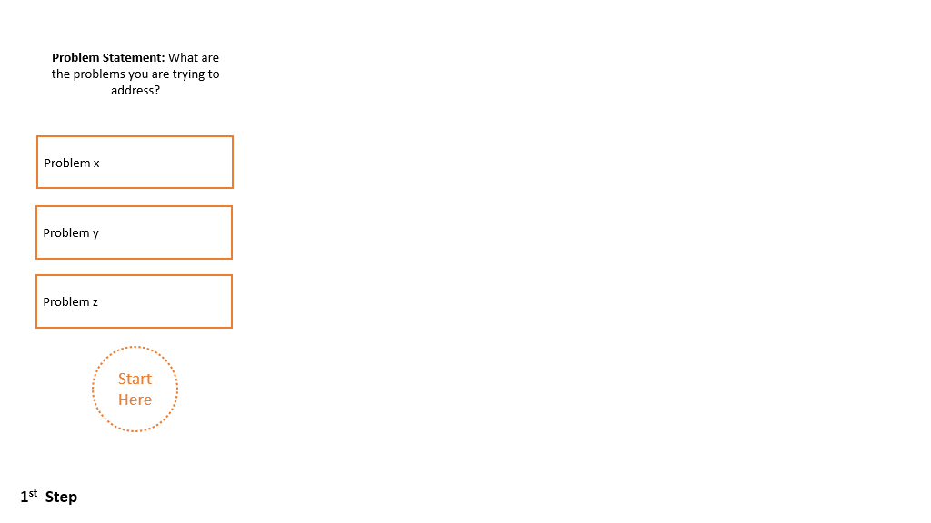

STEP 2 – Identify the Impact/Development objective of your project.

Review the list of problems/challenges identified under Step 1 and then identify a good way to summarize the project's long-term Impact/Development Objective. According to OECD-DAC, Development Objective is the “Intended impact contributing to physical, financial, institutional, social, environmental, or other benefits to a society, community, or group of people via one or more development interventions.”

The Impact/Development Objective of your program is what you intend to contribute to positively changing the problems you described in Step 1. The Impact/Development objective is high-level, long-term, and connected with the problems described in Step 1. It is primarily essential to define what level you might want your program to contribute to. Your Impact/Development Objective should be aligned with the scale and ambition of your project: smaller projects might have Impact objectives that are relatively more limited than bigger interventions.

Your Impact or Development Objective fits with your intervention but typically describes a level of change beyond the scope of your intervention alone: it requires not only your program but the collaboration of other stakeholders, for example. As a rule of thumb, the Impact or Development Objective is precise enough that you can think of one or two ways of assessing it indirectly. Such as, in the concept of community resilience, you probably can think of one or two ways of assessing or measuring if the community is more resilient. Still, such ways do not cover the entire spectrum of resilience, and your project could claim that the real change is only due to your intervention.

For your organization's Theory of Change to be of high quality, the following questions should be addressed:

- What is precisely the long-term Impact Objective that your intervention is trying to achieve? What is a good way of summarizing the overall phenomenon or change you want to contribute?
- Select something high-level that typically goes beyond the scope of your entire project. Still, you can logically claim that if your intervention succeeds, you will contribute positively.

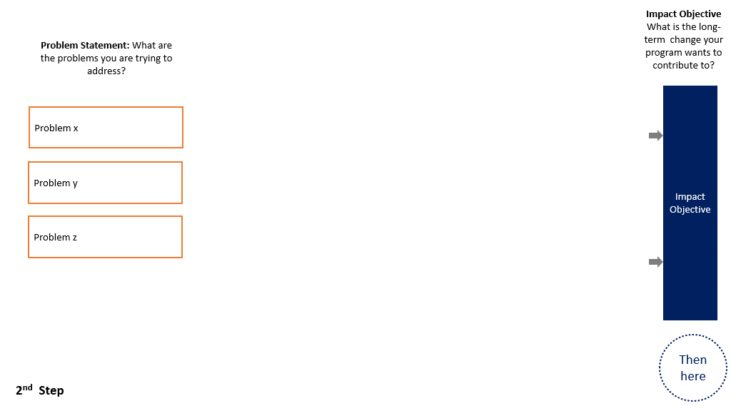

STEP 3 –It is time for outcomes: identify Who needs to change and What needs to change

Review the problems/challenges identified under Step 1 and the overall Impact Objective in Step 2. Now, identify Who (institution, individual, or group of individuals) needs to change and What needs to change in that institution, individual, or group to solve the problems/challenges.

In summary, you need to identify your outcomes. According to OECD-DAC, outcomes are “the likely or achieved short-term and medium-term effects of an intervention’s outputs ."So, essentially, outcomes are not what you do but rather the effect (short or medium-term) of what you do. Think about a mundane example of getting your hair cut: the new haircut is the Output (that will be discussed in the following steps), but its effects: how you (who) might feel more positively about your self-image (what) is the Outcome, for example.

When thinking about outcomes, it is important to think broadly: beyond the target group you might have identified when you identified problems, drivers, and factors. You may have other stakeholders that you believe may also need to change to address the overall need. These stakeholders could include government, community and religious leaders, youth, etc. For example, in the case of a program with returning foreign fighters, besides the key group itself (foreign fighters and their families), some other stakeholders that might need to change to facilitate reintegration could be: the local government that needs to change its local policy and fund services (e.g., psychosocial services); community leaders needs to change from unsupportive to supportive regarding the reintegration of returnees and families, the whole community, itself.

Step 3 is to generate a list of the various stakeholders (i.e., institutions, individuals, and groups of individuals) that need to change in the desired direction for the problem/needs to be adequately addressed. The completion of this step will produce for the organization its Outcome Statements that it believes, if achieved, will adequately address the need and associated problems or challenges identified in Step #1 (e.g., the rehabilitation and reintegration of foreign fighters).

Once the list of Outcome Statements is made, try to think about how you can sequence them. What are the outcomes that need more effort and longer to be achieved? These outcomes are your Intermediary Outcomes/Long-term Outcomes. Which outcomes are more short-term changes you envision achieving? These are your Immediate Outcomes. Once you have classified your outcomes, you should proceed to 'map out in a series of pathways where the achievement of one Outcome Statement may need to happen before another Outcome Statement occur (and possibly identify outcomes statements that were still missing). In short, you should link Intermediary Outcomes/Long-Term Outcomes and Immediate outcomes.

To help you understand which Outcome is which, think about the type of change you are trying to achieve: changes in terms of awareness or knowledge usually are quicker and easier to achieve, thus short-term outcomes. While intermediary outcomes typically are changes in attitudes, behavior, or institutional change because they require more time and effort. Also, intermediary outcomes are a consequence themselves of short-term outcomes. Also, If needed, you can break the Intermediary/Long-term outcomes into two separate columns.

For example, if you are developing a program on youth as change agents of PVE. Your outcome statement is that youth in your region becomes change agents of PVE by spreading the PVE message to their peers; you are looking into a behavioral change. What is missing? These youth must understand PVE before spreading the message (knowledge change). Thus, this Outcome of knowledge change needs to happen before the behavioral change.

The mapping of outcomes in pathways links different outcomes for the same target group and outcomes for different target groups. For example, if your Outcome Statement is that returning Foreign Fighters and their families are integrated into their communities, some parallel outcomes might be local government changing its policies or community leaders supporting reintegration. Such outcomes probably need to occur first to increase the chances of reintegrating the returnees and their families.
The number of Outcome Statements should be limited in recognizing the organization’s limited scope in solving the problems identified for the various population groups the organization believes it can engage with.

For your organization's Theory of Change to be of high quality, the following questions should be addressed:

- Does each Outcome Statement identify the stakeholder including its demographic and geographic area (I.e. individual, groups of individuals, institution), and clearly state the desired direction that the stakeholder needs to change in order to address the problem(s) identified in Step 1? Does it connect to the overall goal in Step 2?
- Has each stakeholder and its desired change (I.e., the Outcome Statements) been arranged logically to show that specific stakeholders need to move in the desired direction before the next stakeholder can move in their desired direction? (e.g., government immigration institutions must first change to accept foreign fighters before those fighters can receive counseling).
- For the same stakeholder (e.g., foreign fighter returnee), are the desired changes arranged logically (e.g., vocational skills acquisition achieved first before increases in income from that vocational skills acquisition)?
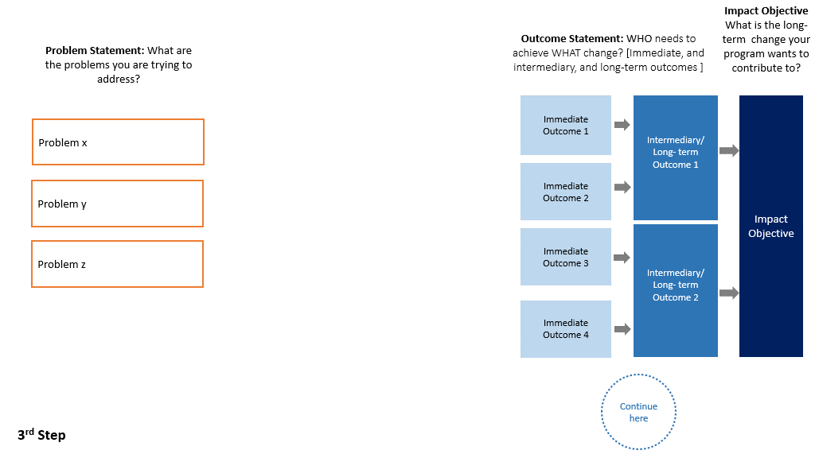

STEP 4 Identify what needs to be done or delivered (Outputs)

For each Outcome Statement, what Outputs does your organization believe need to be delivered to achieve the Outcome? In this step, you and your organization should list the actual “goods and services” that need to be delivered for the outcomes to be achieved. According to OECD-DAC, outputs are “the products, capital goods and services which result from a development intervention; may also include changes resulting from the intervention which are relevant to the achievement of outcomes ."Back to our mundane example of getting your hair cut, the actual haircut is your Output.

In terms of P/CVE, for example, if you and your organization have identified the lack of income as a factor towards violent extremism, one possible outcome statement could be “Youth has enough income to sustain themselves and their families". But to achieve this Outcome, you probably need a short-term outcome such as “Youth acquire income-generating skills ." Vocational skills training workshops would probably be an Output to realize the short-term Outcome of making these youth acquire relevant skills. Therefore, what services need to be delivered to achieve these outcomes?

Outputs are the "goods," 'services," or 'interventions' delivered directly to the target group or institution. The activities necessary to deliver these outputs should not be included in this Theory of Change. For example, a workshop is an Output; this Theory of Change will not include activities such as writing a training manual, hiring the trainer, paying for the training space, and buying the training equipment.

For your organization's Theory of Change to be of high quality, the following questions should be addressed:

- Has each Output or Outputs been distinct from internal 'activities,' and is that Output or Outputs connected to achieving the desired change for each stakeholder?
- Are your outputs goods or services to be delivered by the consortium?

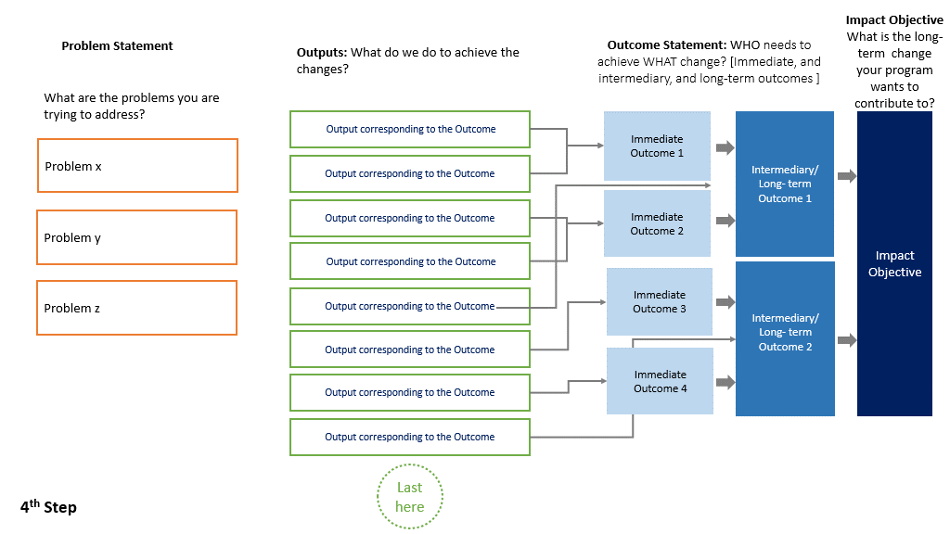
BEFORE you move to the next…..
Your theory of change might likely have become too big. At this point, you and your team must go through an iterative process of the steps above to try to refine the ToC as much as possible. Is it feasible to consider your experience, how many resources you are requesting, and the complexity of the intervention? Is it aligned with the scale and scope of your organization? It should help you narrow down the ToC, possibly dropping outcomes or outputs that are not feasible, would need massive additional resources, or whose achievement would take much longer than the actual grant period.
After this process of refinement, it is possible and likely that your theory of change is still too big to fit into one slide of the template given. This is not a problem. Try to divide your theory of change into broad areas (normally connected to specific intermediary outcomes you are trying to achieve). For example, if your intervention is working at the same time to improve people's income, enhance educational governance and improve the trust of the community in law enforcement: it would be good to separate these three broad areas of work into three “mini-ToCs," each in one different slide page.

STEP 5 Identify the evidence or experience/expertise
In the next step, you and your organization will list the evidence or experience/expertise that you have that shows that if you deliver particular Output that will achieve a certain Outcome or how some outcomes might generate more longer-term outcomes. Thus, the evidence/expertise or experience should be about the connections between outputs and outcomes and outcomes to outcomes.

This list of evidence/experience/expertise should be provided for each Output and Outcome in the list of pieces of evidence box in the Theory of Change flowchart picture. The list of evidence should identify the source, if possible (e.g., Title of the Article/Report). The evidence list does not need to be exhaustive but should help you think how much what you envision is based on actual evidence or not.

For your organization's Theory of Change to be of high quality, the following questions should be addressed:

- Do you have the evidence or experience/expertise from your organization supporting this connection for each arrow? Please include a list per Output and Outcome in the slide.
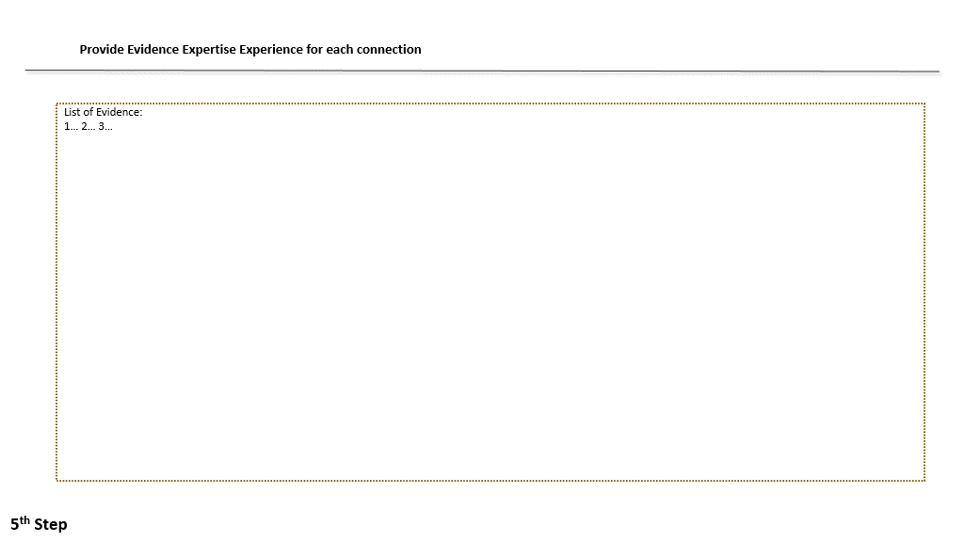

STEP 6 Identify your Assumptions
The next step is to identify your assumptions when you developed your theory of change. This is by far the most challenging element of developing a theory of change, but necessary. According to OECD-DAC, assumptions are “Hypotheses about factors or risks which could affect the progress or success of a development intervention. They can also be understood as hypothesized conditions that bear on the validity of the evaluation itself(…). In theory-based evaluations, assumptions are made explicit where evaluation systematically tracks the anticipated results chain."

In other words, assumptions are what you often implicitly think can affect your intervention's success in delivering the outputs and achieving the outcomes, being often conditions that should be present for the achievement of results (at all levels). Assumptions should be classified into two categories: (1) assumptions that your organization can address, or (2) assumptions that are beyond your control (context inherent).

For example, if you are implementing a program related to women empowerment. Often, there is an implicit assumption that the families (especially the male members) will accept the change in the resources, status, or behavior of the women that are part of the program, but sometimes this is not the case. In this case, such an assumption should be flashed out. You have two options: leave as an assumption, or revisit your Theory of Change to add a component to work with the families of the women you engage to facilitate acceptance.

Some assumptions, however, are beyond your control, such as the ability to work on the ground or host events with a large number of people. Such assumptions are harder to deal with, but describing them might help you later build your risk matrix and understand when some context change might significantly affect your intervention plans. For example, when COVID started, many interventions needed to be re-designed because large concentrations of people were impossible in a pandemic scenario.

Also note that assumptions depend on the level of results: while outcome-level results usually rely on socio-cultural/environmental assumptions, those at the output levels are usually operational/logistical. Moreover, assumptions might evolve during the course of your program, and that is why is so important that you review your Theory of Change routinely once your program starts.

For your organization's Theory of Change to be of high quality, the following questions should be addressed:

- For each Output and Outcome Statement, has the organization identified assumptions that could impede/effect/are strictly necessary to either the delivery of that Output or the achievement of their expected Outcome Statement
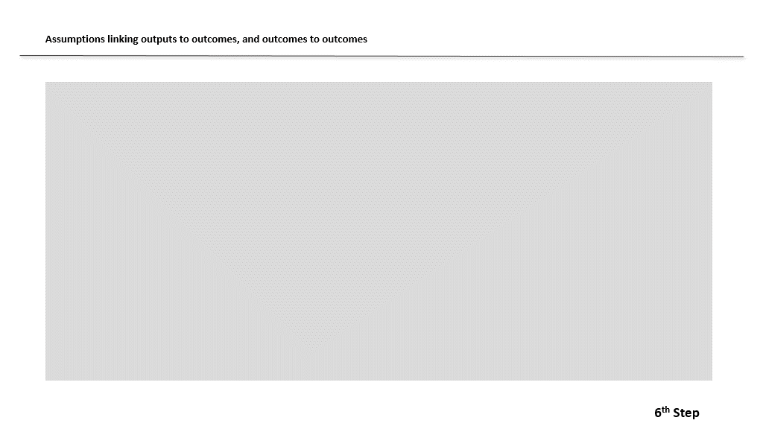

Developing your Theory of Change Flow-Chart

Once you and your organization have completed the above steps, your organization should have an extended Theory of Change, connecting your Outputs with your Outcome Statements. The next step is to refine and focus on the ToC developed. There are some primary considerations your organization might want to consider:

- Considering your organizational capacity, is this Theory of Change too big to be implemented?
- Considering the resources needed, is this Theory of Change unrealistic?
- Considering the list of experience and expertise, does your organization has the necessary experience/expertise to deliver the outputs?
- Considering the evidence listed, is there any output and outcome connection that is very weak?
- Regarding assumptions, is there any that is unlikely to hold? Thus, you need to include working on the issue as an integral part of the ToC.

By answering those questions, you and your organization should start the process of refining and re-focusing your Theory of Change.

Depending on your answers to the questions above, you might need to slash Outcome statements and corresponding Outputs. Suppose you decide not to address a particular outcome. In that case, you might want to think if this would create an additional assumption to the program and add it to the final list in the Theory of Change flowchart.

To facilitate this whole process of revision, you might want to revisit the previous Steps (1 to 6). Finally, after repeating this process once or several times, you will probably end up with a focused, refined, and concise Theory of Change. This is the Theory of Change that should be included in the proposal for GCERF by transferring it to the Theory of Change flowchart style, plus a narrative version explaining the Theory of Change.

OECD DAC, “ Glossary of Key Terms in Evaluation and Results Based Management, 2010. pp 20

