Guidance Note– Developing Theory of Change
Prospective Grant Recipients
GCERF Performance & Impact Unit

Introduction

The purpose of these guidelines is to assist you as a prospective grant recipient to develop your Theory of Change. GCERF believes a well-developed Theory of Change is critical in achieving effective monitoring of performance and impact for the grant recipient’s project activities.

Developing a Theory of Change is a group/organization process that you and your organization should complete. Ultimately, you and your organization as a grant recipient should own your Theory of Change by stating confidently ‘Why we are doing what we are doing?

Developing a Theory of Change is an iterative process where the guidelines followed here may need to be repeated several times. The expectation is that with each repetition, your Theory of Change will come closer to reaching the desired result of a well-developed Theory of Change.

The guidelines provided here will enable you as a prospective grant recipient to complete a draft Theory of Change as part of the concept note that is to be submitted to GCERF for consideration to receive funding. These guidelines will enable you and your organization to produce a Theory of Change of high-quality if they are followed.

The various steps in developing a Theory of Change are listed below along with details for each step. The first section “Process Phase for Developing Theory of Change” will guide you to brainstorm and generate a bigger Theory of Change, creating an exhaustive list of problems, outcomes and outputs. The following section “Developing a Theory of Change” will guide you from this brainstormed and large Theory of Change to a more focused- Theory of Change (see flowchart).
Outcome: The likely or achieved short-term and medium-term effects of an intervention’s outputs. (OECD DAC Glossary of Key Terms in Evaluation and Results Based Management)
Outputs: The products, capital goods and services which result from a development intervention; may also include changes resulting from the intervention which are relevant to the achievement of outcomes (OECD DAC Glossary of Key Terms in Evaluation and Results Based Management)
Difference: Thus, outputs are the actual goods and services delivered, for example, workshops, radio broadcasts. The outcome is the consequence of these outputs, for example, the change in knowledge of youth after attending a workshop, or the change in their perception or behavior after listening to radio episodes.

Process phase for developing a Theory of Change

STEP 1 – Identify the problems/challenges

Based on a review of the Country Needs Assessment/Country Strategy/overarching country-level Theory of Change (if available/applicable), generate a list of problems/challenges associated with a need or challenge that has been identified in these documents. Even with these documents, brainstorming is also encouraged given the emerging field of P/CVE.

For example, the general need or challenge could be the need to rehabilitate and reintegrate foreign terrorist fighters (FTFs) upon return to their home country. The list of problems/challenges generated could include the lack of psycho-social counselling for these FTFs as well as their families, the lack of jobs and training opportunities for these FTFs, and the absence of government policies to support reintegration.

For your organization’s Theory of Change to be of high-quality, the following questions should be addressed:

- Does your organization have either evidence to refer to (this could include reference to GCERF documents, if available) or experience/expertise that supports your claim that these problems are present and that these problems are associated with the general need or challenge identified? (e.g. the various problems/drivers/factors that contribute to violent extremism).

STEP 2 – Identify the Who needs to change and What needs to change

Review the list of problems/challenges identified under Step 1 and identify Who (institution, individual, or group of individuals) that needs to change and What needs to change in that institution, individual, or group of individuals to solve the problems/challenges listed in #1. This should be a brainstorming, exhaustive exercise completed by all relevant staff so that the problems/challenges identified in #1 are adequately addressed by the organization as a group.

From Step 1 where you identified the general need or challenge and the associated problems/drivers/factors that contribute to that need, your organization may have already identified the key target group. But you may have other stakeholders that you believe may also need to change to address the overall need. These stakeholders could include government; community and religious leaders, youth, etc…

For example, in the case of returning foreign fighters, besides the key group itself (foreign fighters and their families), some other stakeholders that might need to change in order to facilitate reintegration could be: the local government that needs to change its local policy and fund services (e.g.; psychosocial services) to support reintegration; community leaders needs to change from unsupportive to supportive regarding the reintegration of returnees and families, etc…

The purpose of Step 2 is to generate a list of the various stakeholders (i.e. institutions, individuals, and groups of individuals) that need to change in a desired direction for the problem/needs to be adequately addressed. The completion of this step will produce for the organization its Outcome Statements that it believes, if achieved, will adequately address the need and associated problems or challenges that have been identified in Step #1 (e.g. the rehabilitation and reintegration of foreign fighters).

The number of Outcome Statements should be limited in number recognizing the organization’s limited scope in solving the problems identified for the various population groups that the organization believes it can engage with.

For your organization’s Theory of Change to be of high-quality, the following questions should be addressed:

- Does each Outcome Statement identify the stakeholder including its demographic and geographic area (I.e. individual, groups of individuals, institution) and clearly state the desired direction that the stakeholder needs to change in order to address the problem(s) identified in Step 1?

STEP 3 Do the Outcome / Stakeholder Mapping

Step 3 is the process of mapping outcomes and stakeholders. You and your organization should review the Outcome Statements from Step 2 to see how they fit in an ordered sequence in addressing the need and problems identified in Step #1. Also, you should assess if you missed in the list of Outcome Statements from Step 2, any intermediary outcome that needs to happen in order to enable a certain outcome.

These various Outcome Statements should be ‘mapped out’ in a series of pathways where the achievement of one Outcome Statement may first need to happen before another Outcome Statement occur (and possibly identify outcomes statements that were still missing). See the flowchart for an example in which the outcomes were numbered according to the sequence.

For example, in case your developing a program on youth as change agents of PVE, and your outcome statement is that youth in your region becomes change-agents of PVE by spreading PVE message to their peers, you are looking into a behavioral change. What is missing? Probably, these youth need first to understand what PVE before they start spreading the message (knowledge change). Thus, this outcome on knowledge change needs to happen before the behavioral change.

The mapping of outcomes in pathways links not only different outcomes for the same target group, but also outcomes for different targets groups. For example, if your Outcome Statement is that returning Foreign Fighters and their families are integrated into their communities, some outcomes such as local government changing its policies, or community leaders supporting reintegration probably need to occur first, in order to increase the chances of achieving the reintegration of the returnees and their families.
For your organization’s Theory of Change to be of high-quality, the following questions should be addressed:

- Has each stakeholder and its desired change (I.e. the Outcome Statements) been arranged in a logical order showing that certain stakeholders need to move in the desired direction before the next stakeholder can move in their desired direction? (e.g. government immigration institutions first have to change to accept foreign fighters before those fighters can receive counselling).
- For the same stakeholder (e.g. foreign fighter returnee) are the desired changes arranged in a logical order (e.g. vocational skills acquisition achieved first before increases in income from that vocational skills acquisition)?

STEP 4 Identify what needs to be done or delivered (Outputs)

For each Outcome Statement, what Outputs does your organization believe need to be delivered to achieve the Outcome? Thus, in this step, you and your organization should list what are the actual “goods and services” that need to be delivered for the outcomes to achieved.

For example, if you and your organisation have identified see the lack of income as a factor towards violent extremism, one possible outcome statement could be “Youth has enough income to sustain themselves and their families”. But to achieve this outcome, you probably need an intermediary outcome such as “Youth acquire income-generating skills”. Therefore, what are the services that need to delivered to achieve these outcomes? Probably, vocational skills training workshops would be an Output to realize the intermediary outcome of making these youth acquire relevant skills.

Prior activities necessary to deliver these outputs, which can be called activity-means would not be included in the Theory of Change. For example, a workshop is an Output, activities such as writing a training manual, hiring the trainer, paying for the training space, and buying the training equipment will not be included in this Theory of Change. Outputs are the “goods”, “‘services”, or ‘interventions’ delivered directly to the target group or institution.

For your organization’s Theory of Change to be of high-quality, the following questions should be addressed:

- Has each Output or Outputs been shown to be clearly distinct from internal ‘activities’ and is that Output or Outputs clearly connected to the achievement of the desired change for each stakeholder?

STEP 5 Identify the evidence or experience/expertise
In the next step, you and your organization will list the evidence or experience/expertise that you have that shows that if you deliver certain Output you will achieve this Outcome. Based on the strength of this evidence, experience and/or expertise, your organization will link Outputs to Outcomes with arrows that will show the strength of this connection. See the questions below.

For your organization’s Theory of Change to be of high-quality, the following questions should be addressed:

- For each Output have we provided an arrow connecting this Output to an Outcome Statement? For each arrow do you have the evidence or experience/expertise from your organization (maximum of 3 per Output) that supports this connection?
- For each arrow, have you reviewed the evidence/experience/expertise to assign either a strong connection (green arrow), moderate connection (orange arrow), or weak or unknown connection (red arrow) ?

Green arrows would suggest that your organization is confident that if you deliver the Outputs you will achieve the Outcome based on the evidence/experience/expertise you have provided and reviewed. GCERF does not discourage red arrows as we recognize that PVE is an emerging field. We only ask that organizations make the effort to estimate the strength of connection between the Outputs they propose to deliver and the expected Outcomes they plan to achieve from those Outputs.
This list of evidence/experience/expertise should be provided for each Output in the list of evidences box in the Theory of Change flow-chart picture. The list of evidence should identify the source (e.g.; Title of the Article/Report).

STEP 6 Identify the Barriers
The next step is to identify the barriers that could impede the delivery of your Outputs or the achievement of your expected Outcomes. What are the barriers that could impede the delivery of Outputs and the achievement of the Outcomes? This should be done for each Output and Outcome Statement.

These barriers should be then classified in two categories. The first category is barriers that your organization can address, and the second category is barriers in which are beyond your control. For the first category, you might want to rethink in terms of outcomes and outputs how to address those barriers, integrating it into your actual program.

For the second category, barriers beyond your control, you will list these potential barriers for each Output and Outcome in the Theory of Change flowchart. If there are some barriers in the first category that could be addressed but you consider it is as beyond the scope of the program, they could be listed in the Theory of Change as well.
For your organization’s Theory of Change to be of high-quality, the following questions should be addressed:

- For each Output and Outcome Statement has the organization identified barriers beyond the organization’s control that could impede either the delivery of that Output or the achievement of their expected Outcome Statement?

Developing your Theory of Change Flow-Chart

Once your organization has completed the above steps, your organization should have an extended Theory of Change, connecting your Outputs with your Outcome Statements using the evidence/experience/expertise colored arrows. (see the example at the end of these guidelines).

The next step is to refine and focus the ToC developed. There are some main considerations your organization might want to consider:

- Considering your organizational capacity, is this Theory of Change too big to be implemented?
- Considering the resources needed, is this Theory of Change unrealistic?
- Considering the list of experience and expertise, does your organization has the necessary experience/expertise to deliver the outputs?
- Considering the evidence listed, is there any output and outcome connection which is very weak?

By answering those questions, you and your organization should start the process of refining and re-focusing your Theory of Change. You might need to slash Outcome statements and corresponding Outputs, depending on your answers to the questions above.

To facilitate this process, you might want to revisit each the previous Steps (1 to 6). In case you decide to not address a particular outcome, you might want to think if this would create an additional barrier to the program, and add to the final list in the Theory of Change flowchart.

Finally, after repeating this process once or several times, your organization will probably end-up with a focused, refined and concise Theory of Change. This is the Theory of Change that should be included in the proposal for GCERF by transferring it to the Theory of Change flowchart style pictured below, plus a narrative version explaining the Theory of Change.

In the picture below, each component is linked with a Step (1-6), numbered accordingly to the Steps explained in the previous section.

Note: The ToC flow-chart picture below is only an example to guide an organization in developing a Theory of Change flow-chart picture.
This example does not indicate a preference by GCERF. GCERF encourages organizations to propose a variety of different interventions reflecting its own local context and experience in preventing violent extremism.

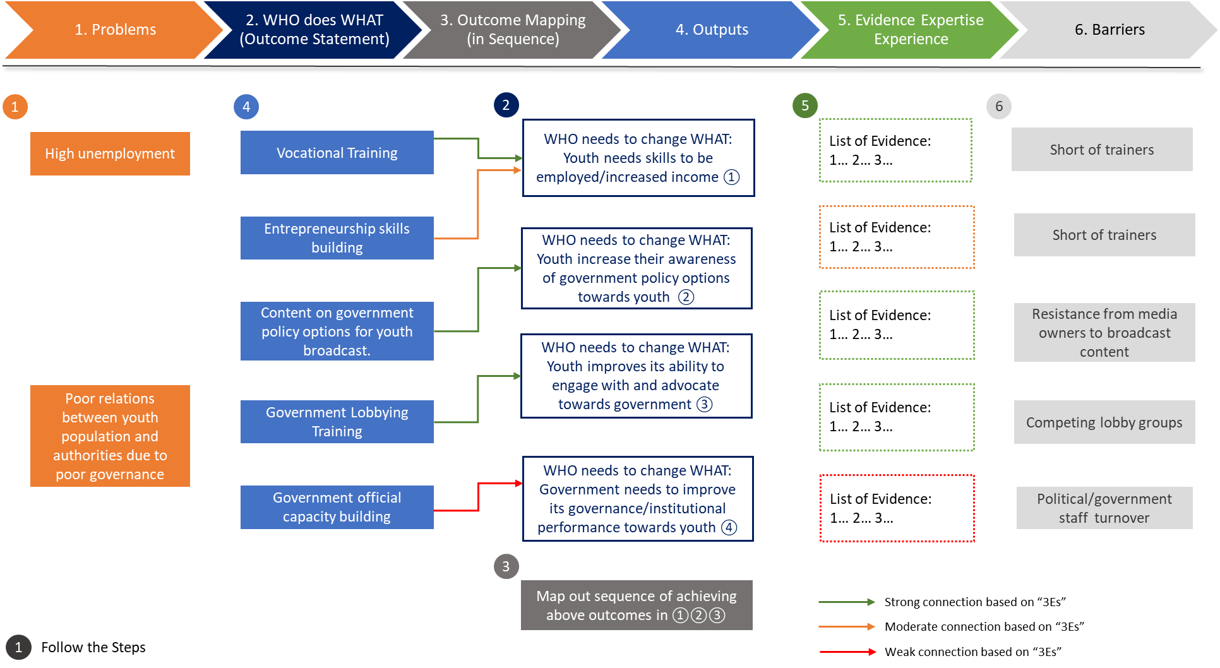

A blank Theory of Change flow-chart picture will be provided in PowerPoint to prospective grant recipients to aid them in completing their Theory of Change.

