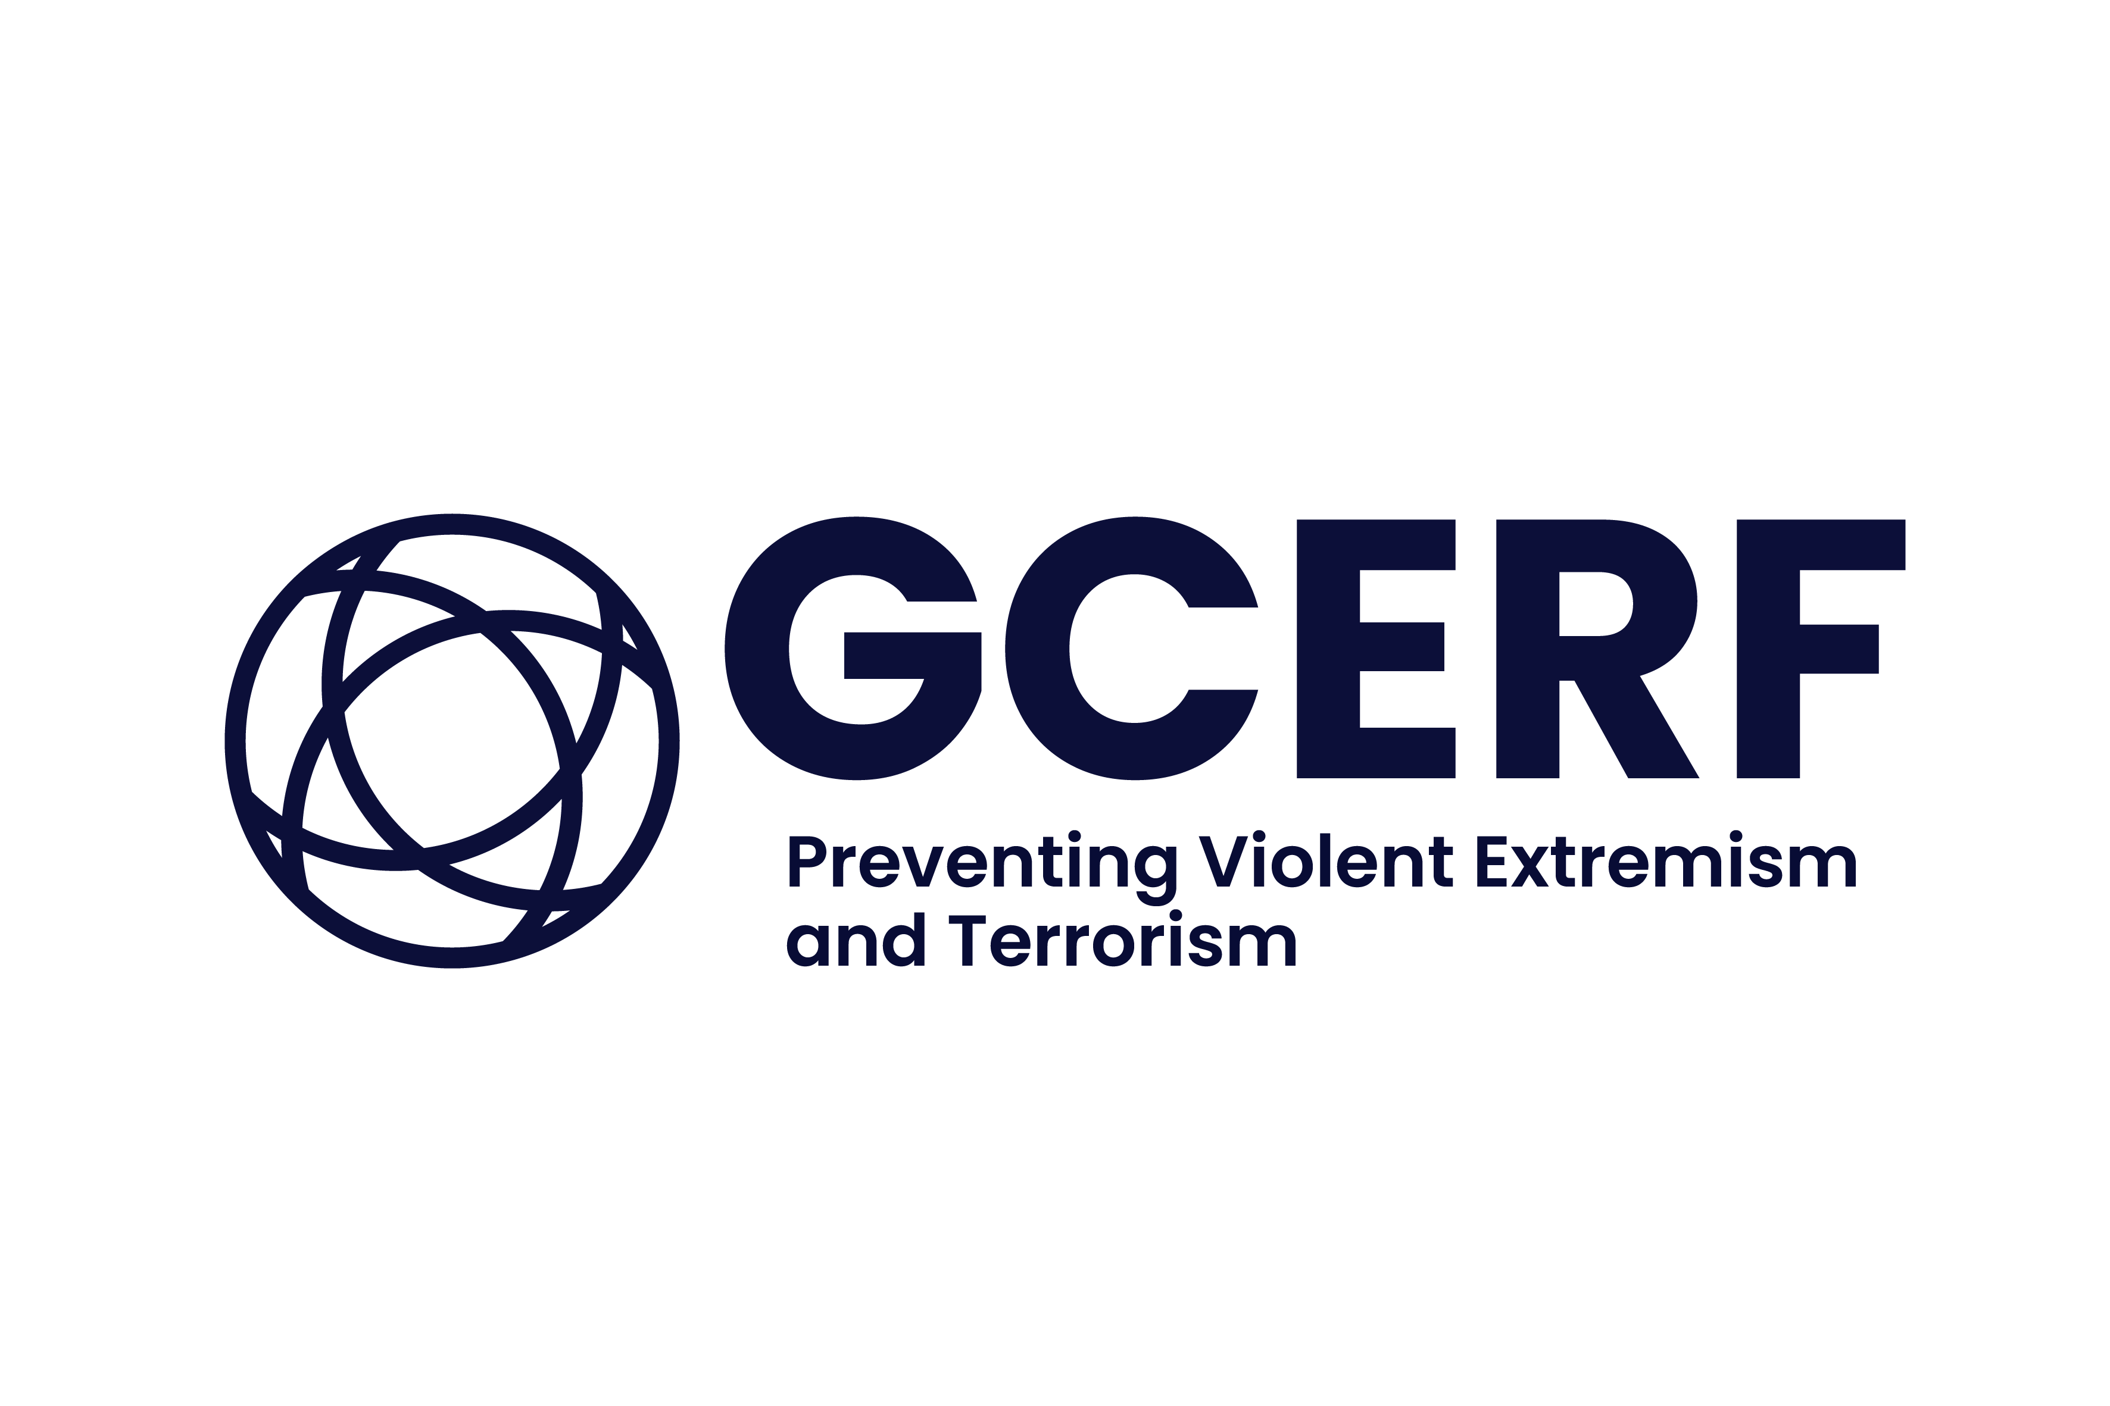

**SOMALIA**

**CALL FOR EXPRESSIONS OF INTEREST**

GCERF invites Civil Society Organisations (CSOs) in Somalia to apply for funding to implement prevention programmes that promote preventive approaches to radicalisation and violent extremism.

**APPLICATION DEADLINE: 14 September 2025-** **11:59 PM (CET)**

**Background**

The Global Community Engagement and Resilience Fund (GCERF) was established in 2014 to prevent violent extremism. GCERF is a not-for-profit Swiss foundation that supports local, community-level initiatives that address the local drivers of violent extremism and strengthen resilience against violent extremist agendas.

**Call for EOIs**

GCERF has been funding programmes in Somalia since 2021 and has two ongoing grants in Southwest and Hirshabelle regions, respectively.

In every partner country, GCERF’s investments are overseen by Country Support Mechanisms (CSMs), which are multi-stakeholder forums that bring together government, donors, civil society and academics. In Somalia, the CSM is chaired by the Director of Tubsan National Centre for Prevention and Countering Violent Extremism under the Office of the Prime Minister, with whom GCERF works closely at both the strategic and programmatic levels.

GCERF funds CSOs, either directly or in consortia, to implement initiatives aimed at preventing violent extremism. Consortium grants are managed by “Principal Recipients” (PRs), who are the legal recipients of GCERF funding. PRs then disburse funds and provide support to “Sub-Recipients” (SRs). “Recipients” of GCERF funding include “Principal Recipients” and “Sub-Recipients” in the context of a grant to a consortium and “Direct Grantees” that receive funding from GCERF but do not lead a consortium.

The purpose of this Expression of Interest (EOI) is for applicants to demonstrate they meet GCERF’s prerequisites to receive funding and that they have sufficient technical, managerial and administrative experience to effectively implement a programme that will seek to address the issues outlined below.

Received application forms will be evaluated against standardised criteria, and applicants will be duly informed whether their proposals will move to the next stage of evaluation. This stage will include working with GCERF to add further detail to the programme design and budget.

As per GCERF’s [**Investment Strategy for Somalia**](https://www.gcerf.org/wp-content/uploads/2015/12/Annex-A_GCERF-Strategy-for-Investment-in-Somalia-2025-2028.pdf)and in support of Somalia’s National Strategy and Action Plan to Prevent and Counter Violent Extremism, the focus of our funding will be as follows:

**WHO**

* **Youth and children** (in and out of school) who are at risk of becoming violent extremists and criminals. - The African Youth Charter defines youth as persons between the ages of 15 and 35 (African Union 2006), and the United Nations Convention on the Rights of the Child defines a child as a human being below the age of 18 years. (For more detail, see GCERF Somalia Investment Strategy, p.22).
* **Women and girls** who facelimited access to economic independence, intensifying their susceptibility to and fear of violence and/or exploitation
* **Clan leaders/traditional and religious leaders** who are connected to the youth and can generate a positive impact on youth as role models. (For more detail, see GCERF Somalia Investment Strategy, p.22)
* **Marginalised Minority Groups** who often face systemic discrimination (For more detail, see GCERF Somalia Investment Strategy, p. 22)
* **Internally Displaced Persons (IDPs) and the Urban Poor** who are vulnerable to extremism due to their precarious living conditions, risk of eviction and lack of access to essential services (For more detail, see GCERF Somalia Investment Strategy, p. 22)

Note: girls and women affected by non-state armed groups, including violent extremist groups, should be included in the different categories to the extent possible.

**WHERE**

* **Urban areas** in Baay and Bakool of the Southwest state ONLY
* **Rural areas** that are under the control of national authorities and identified as a place for recruitment for non-state armed groups in Baay and Bakool ONLY

**WHAT**

GCERF seeks to fund local civil society organisations to implement programmes that support the social and economic recovery and reintegration of communities who are at risk of recruitment and radicalisation.

We intend to support a programme that will:

* **Increase positive engagement between members of different groups,** through improved effectiveness of conflict prevention and reconciliation mechanisms;
* **Improve socio-economic opportunities** for young people and women who are at risk of radicalisation and/or recruitment;
* Offer alternative messaging, including on culture, religion, cohesion, and tolerance and awareness of messaging that reinforces **positive narratives** by engaging with religious/community leaders
* Promote the role of **religious leaders in PVE**:
  + Outreach to the religious leaders
  + Support the creation of and management plans for ulama mobilisation units in the targeted areas

*Note: This list is non-exhaustive, and this EOI is open to other innovative PVE programme proposals.*

***HOW***

Applicants should refer to the ‘Guiding Principles’ described on page 7 of the Investment Strategy for Somalia. **Applicants should demonstrate understanding of:**

* The main issues that communities in the targeted areas face that increase their risk of recruitment and radicalisation;
* How and why proposed activities will address these issues; and
* What knowledge, experience and/or networks your organisation has in Southwest state that make you best placed to implement this programme.

Proposals should demonstrate knowledge of previously established or existing mechanisms, platforms and capacities of communities and authorities and how these will be built on or improved. In addition, proposed activities should demonstrate linkages to Somalia’s National Strategy and Action Plan to Prevent and Counter Violent Extremism.

The safety and security of any staff or programme participants/beneficiaries should be considered in programme design. **We encourage applicants to think innovatively and in response to the current needs and priorities**.

**Grant size and duration**

The proposed programme should cover a period of between 2 and 2 and a half years – 24 to 28 months. We intend to issue grants to organisations in South West for up to 1,000,000 USD, over the duration of the grant period. This amount may increase, subject to grantee performance and availability of funds.

**Grantee**

Each consortium should be led by a Principal Recipient that will be responsible for providing subgrants to other consortium members. Priority will be given to organisations with proven successful PVE experience and organisations based in the Southwest State.

**Expressions of Interest**

The purpose of an Expression of Interest is for an applicant for GCERF funding to demonstrate that it meets GCERF’s established prerequisites and that it possesses the required capabilities to be a Principal Recipient of GCERF funding.

|  |
| --- |
| **PREREQUISITES** |
| 1. Appropriate legal registration in both the proposed FMS and with the Federal Government of Somalia. |
| 1. Willingness to accept and fulfil the role of a Principal Recipient if applying in a consortium. |
| **REQUIRED CAPABILITIES** |
| 1. Established relationships and credibility with the communities and population groups identified in the Call, in the geographical areas also identified in the Call. |
| 1. Previous experience and capacity in programme design and management, and project cycle management. |
| 1. Experience and capacity in financial management and in the management of and accounting for international donor grant funding. |
| 1. Experience and capacity in working within a consortium and/or managing sub-recipients for those choosing to form a consortium. |
| 1. Experience and capacity in community-level initiatives that address the local drivers of violent extremism and strengthen resilience against violent extremist agendas. |
| 1. Knowledge of local languages is an asset |

**How to Submit an Expression of Interest**

All Expressions of Interest must be duly filled and submitted electronically to [**call.somalia@gcerf.org**](mailto:call.somalia@gcerf.org)by **14 September 2025**. The email should be marked as ‘**EOI-SOMALIA 2025**’ in the subject line. Failing to do so might compromise your submission. Shortlisted applicants will be contacted to take part in a due diligence assessment.

**Please ensure that your application includes the following documents:**

* Completed Annex A (Application form)
* Copies of organisational registration documents
* Latest Audit Reports
* Theory of Change in GCERF template
* Proposed organisation chart for the project (not for your organisation)
* Completed Annex B (Details of your past projects)
* Completed Annex C (Proposed budget)

**If any part of the form or process is unclear, please email requests for clarification or further detail to** [**contact.somalia@gcerf.org**](mailto:call.somalia@gcerf.org)**.**

We plan to hold an online information session on **1 September 2025 at 3 pm (CET)/4 pm (EAT)**. If you wish to participate, submit your request to [**contact.somalia@gcerf.org**](mailto:contact.somalia@gcerf.org)**.**

Following the review of submissions, shortlisted applicants will be contacted for due diligence.